NAME: HARSHINI P R REG NO: 192524165
COURSE CODE: CSA0603 COURSE NAME: DAA

LAB PROGRAMS SESSION – 2

1. arr = [1, 2, 2, 3, 4, 3, 5]
unique = []

for i in arr:
if i not in unique:
unique.append(i)

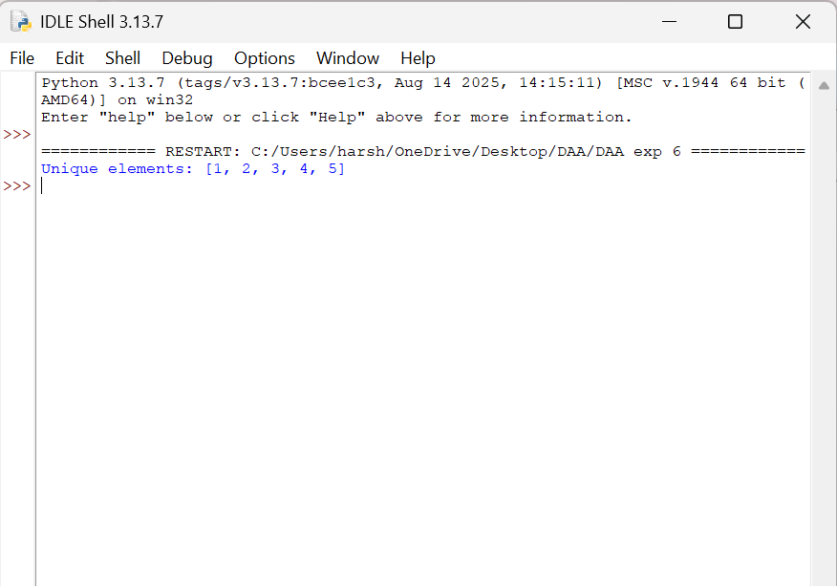
print("Unique elements:", unique)

2. arr = [5, 2, 4, 1, 3]

for i in range(len(arr)):
for j in range(len(arr) - i - 1):
if arr[j] > arr[j + 1]:
arr[j], arr[j + 1] = arr[j + 1], arr[j]

print("Sorted array:", arr)

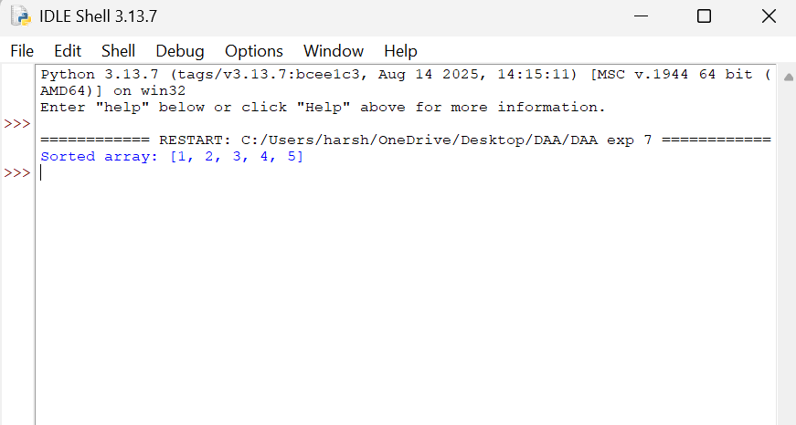

3. arr = [10, 20, 30, 40, 50]
x = 30
low = 0
high = len(arr) - 1
found = False
while low <= high:
mid = (low + high) // 2
if arr[mid] == x:
found = True
break
elif arr[mid] < x:
low = mid + 1
else:
high = mid - 1
if found:
print("Element found")
else:
print("Element not found")
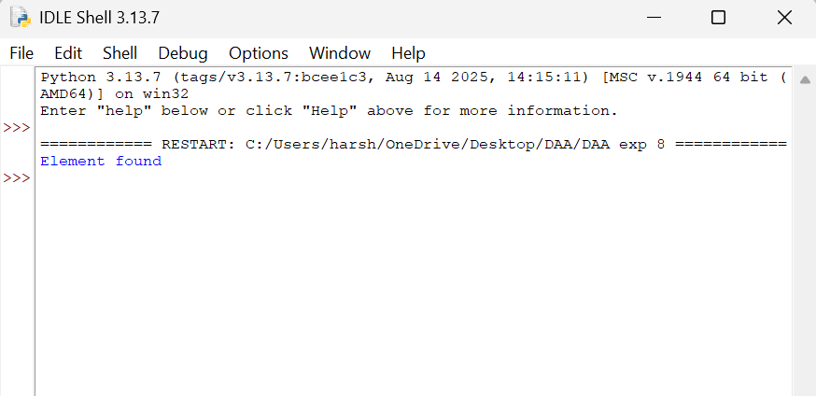
4. def merge_sort(arr):
if len(arr) <= 1:
return arr
mid = len(arr) // 2
left = merge_sort(arr[:mid])
right = merge_sort(arr[mid:])
result = []
while left and right:
if left[0] < right[0]:
result.append(left.pop(0))
else:
result.append(right.pop(0))
return result + left + right
nums = [5, 2, 8, 1, 3]
print("Sorted array:", merge_sort(nums))
